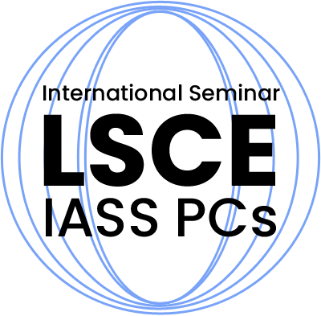 | First announcement Olsztyn, 31 May 2019
XXV Jubilee Conference on
Lightweight Structures in Civil Engineering
University of Warmia and Mazury
Olsztyn, 6th of December 2019

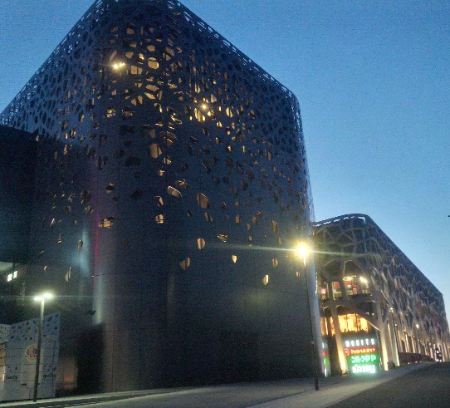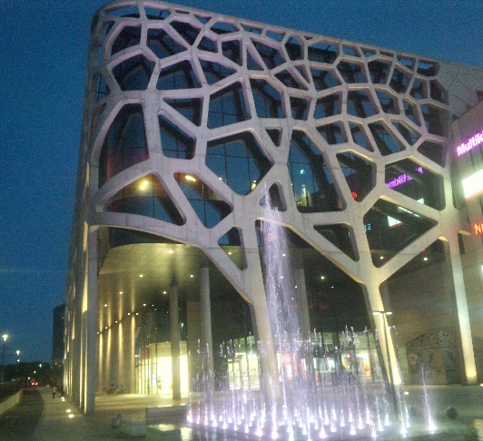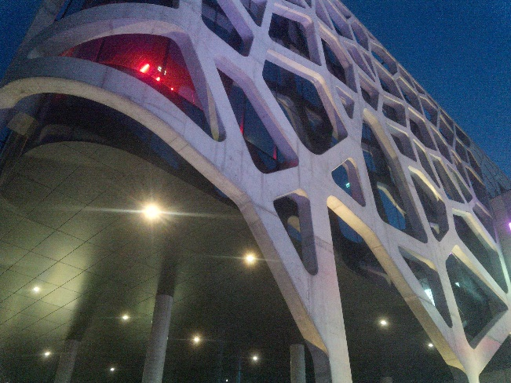
▷ Basic information:
The seminars Lightweight Structures in Civil Engineering are annual meetings organized by the Permanent Organizing Committee of Polish Chapters of the International Association of Shell and Spatial Structures (IASS). For 25 years, since the first conference organized by prof. Jan B. Obrębski in 1995, the meetings have been giving the opportunity to exchange knowledge and to integrate researchers from different scientific fields, research centres and countries. Today, after a quarter of a century, the organizing committee is proud to cordially invite you all to participate in this jubilee event.
▷ Topics:
Engineering objects erected with relatively small amount of build-in-material and assuring simultaneously extremely high exploitation parameters i.e.: spatial lattice structures, plate and shell structures, domes and membranes, high-rise buildings, towers, chimneys, reservoirs, bridges, thin-walled, tension, cable and pneumatic structures. All types of analysis methods are accepted: analytical, numerical and experimental. Researchers from all related fields are invited: architects, civil engineers, economists, managers etc.
▷ Important dates in 2019:  September 15th – submission of abstract  October 1st – initial approval of abstracts  October 20th – full paper submission deadline |  | ▷ Publication form:  The book of abstracts and the peer-reviewed scientific monograph in English language with official number of ISBN.
▷ Fees*:  Participants – 130 Euro (or 550 PLN), accompanying person – 100 Euro (or 400 PLN), second paper – 65 Euro (or 275 PLN) |  | ▷ Language:  English for abstracts and monograph, and Polish or English for presentation
*participation, book of abstracts, monograph, coffee breaks, lunch and dinner included
▷ Organizers:  University of Warmia and Mazury: Faculty of Geodesy, Geospatial and Civil Engineering |  | ▷ Conference place:  HP Park Hotel,  119 Warszawska street, 10-701 Olsztyn
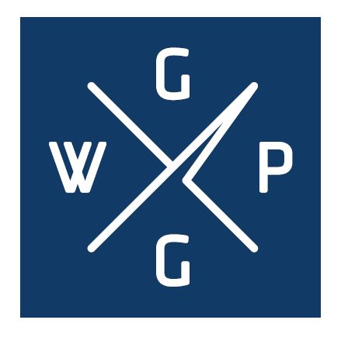 | ▷ Additional information at:  www.lsce.pl/en  lsce@uwm.edu.pl  For the 25th time, we look forward to seeing you on LSCE in 2019!

